**12-7 notes**

Extract, Transform, and Load

Goals:

* Extract data by using Python and Pandas.
* Transform and clean data by using Python and Pandas.
* Parse string data into a Python dictionary.
* Use list comprehensions to make code more readable.
* Use regular expressions to manipulate string data.

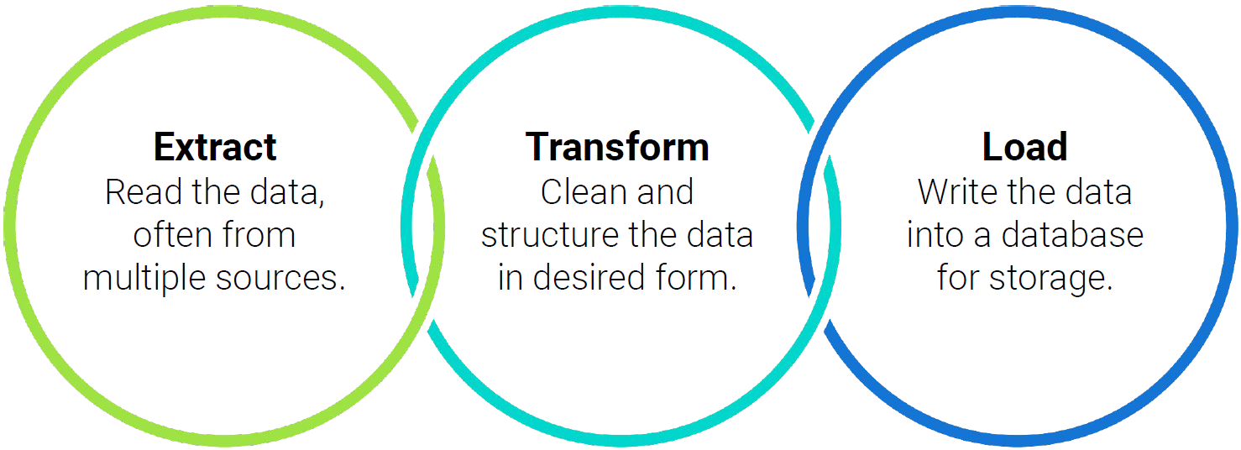

**Transform and Clean Online Orders Solution:**

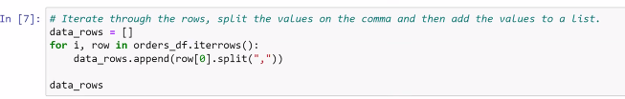

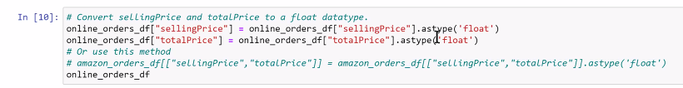



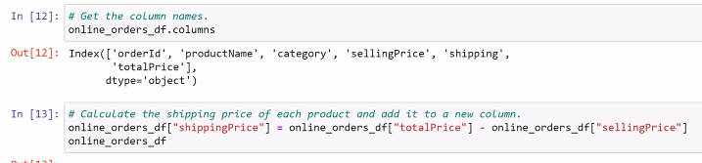



List comprehensions are VERY helpful. They’re make or break.

If you can do it in 1 line (list comprehension), why would you do it with a complicated For loop?

Q- List comprehension student activity IN [4]- how to split a list?

Review 7:50-7:55pm in recording

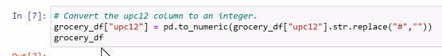

***REGEX TIME!!!***

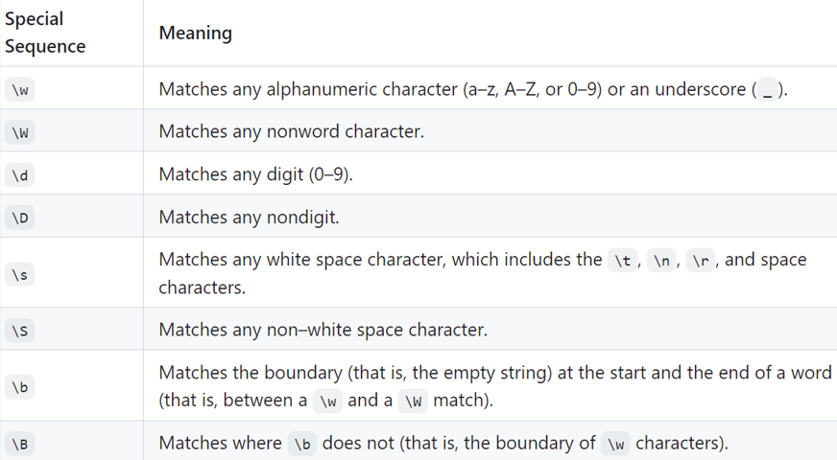

**Basic Regex Pattern Matching solution:**

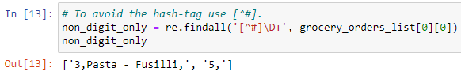

^ 3 and 5 are included because the data type is not int.

Challenge- Send Carson a regex string that removes a suffix (jr, sr, the third) from after a first and last name.

**Regex Pandas Solution:**

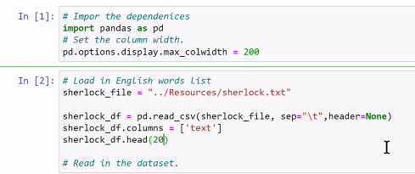

^ You can read in a .txt file using the code above (tricking it into thinking it’s a CSV)

You can use regex within pandas without importing re

